
CPEN313 – Computer Embedded Systems

Project:
Bitonic Sorting Algorithm

Presented to
Dr. Rafic Ayoubi
By
Antonio Makary

16/5/2023
Contents
Table of tables: 3
Table of figures: 4
Objective: 5
Introduction 5
Description: 7
Hardware schematic: 7
State machine: 10
Alternative solutions: 11
Simulation: 12
Conclusion: 13
Code: 13

Table of tables:
Table 1 example on bitonic sort 5
Table 2 compare block table 7
Table 3 in0 and in1 table 7
Table 4 mux inputs to the compare blocks 8
Table 5 feedback registers 8
Table 6 relation between counter and states 10
Table 7 relation between counter and a_d 10

Table of figures:
Figure 1 top level shcematic of the bitonic sorter 8
Figure 2 compare block 8
Figure 3 relation between s1 and s2 10
Figure 4 state machine 11
Figure 5 input values 13
Figure 6 ouput values 13

Objective:
The objective of this project is to design and implement a bitonic sorter, using the bitonic sorting algorithm using SystemVerilog, and provide a simulation for its functionality with Quartus software. This report will aim at providing an explanation of the design as well as a discussion of the simulation results. A hardware schematic is also provided so we can visualize the design.

Introduction
Sorting algorithms are fundamental procedures used in computer science to arrange elements in a specific order. Sorting is essential for organizing and retrieving data efficiently. There are various sorting algorithms, each with its own advantages and disadvantages, suited for different scenarios depending on factors like input size, data type, and desired efficiency. One of the popular sorting algorithms is Bitonic sort which is a parallel sorting algorithm that is particularly effective on parallel computing architectures. It is a comparison-based sorting algorithm that relies on the concept of bitonic sequences. A bitonic sequence is defined as a sequence of elements that first monotonically increases and then monotonically decreases, or vice versa. For example, [1, 3, 5, 4, 2] is a bitonic sequence because it first increases (1, 3, 5) and then decreases (4, 2). Bitonic Sort works by recursively dividing a sequence into bitonic sub-sequences, sorting them, and then merging them back together to form a sorted sequence.
Bitonic Sort's inherent parallelism makes it an attractive choice for FPGA implementations. FPGAs excel at parallel processing due to their ability to perform multiple operations simultaneously. Bitonic Sort's parallel nature allows for efficient utilization of the FPGA's parallel resources.
In FPGA implementations of Bitonic Sort, the sequence is typically divided into smaller bitonic sequences, and sorting and merging operations are performed concurrently on different parts of the sequence. Each element comparison and swapping operation can be implemented as a separate processing unit within the FPGA, enabling efficient parallel execution.
In this report we will be explaining how we designed the bitonic sorter and explaining our design choices and explain the simulation we will be making as well as explaining the results
The table below provides a simple example of how a bitonic sorter perform the sorting on a sequence of 16 numbers permuted randomly:
Table 1 example on bitonic sort
Step | Sequence | Comparisons and Swaps
1 | [4, 1, 6, 2, 8, 3, 7, 5, 12, 9, 14, 10, 16, 11, 15, 13] | Compare & Swap: (4, 1), (6, 2), (8, 3), (7, 5), (12, 9), (14, 10), (16, 11), (15, 13)
2 | [1, 4, 2, 6, 3, 8, 5, 7, 9, 12, 10, 14, 11, 16, 13, 15] | Compare & Swap: (1, 4), (2, 6), (3, 8), (5, 7), (9, 12), (10, 14), (11, 16), (13, 15)
3 | [1, 2, 3, 4, 5, 6, 7, 8, 9, 10, 11, 12, 13, 14, 15, 16]

Description:

Hardware schematic:
In this section we will show the hardware design that was made to implement the Bitonic sorter including each part.
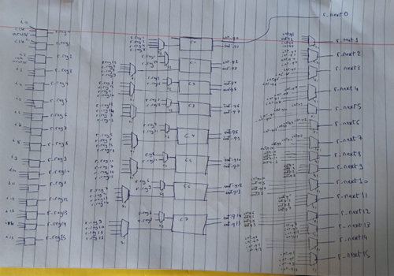
Figure 1 top level shcematic of the bitonic sorter
.
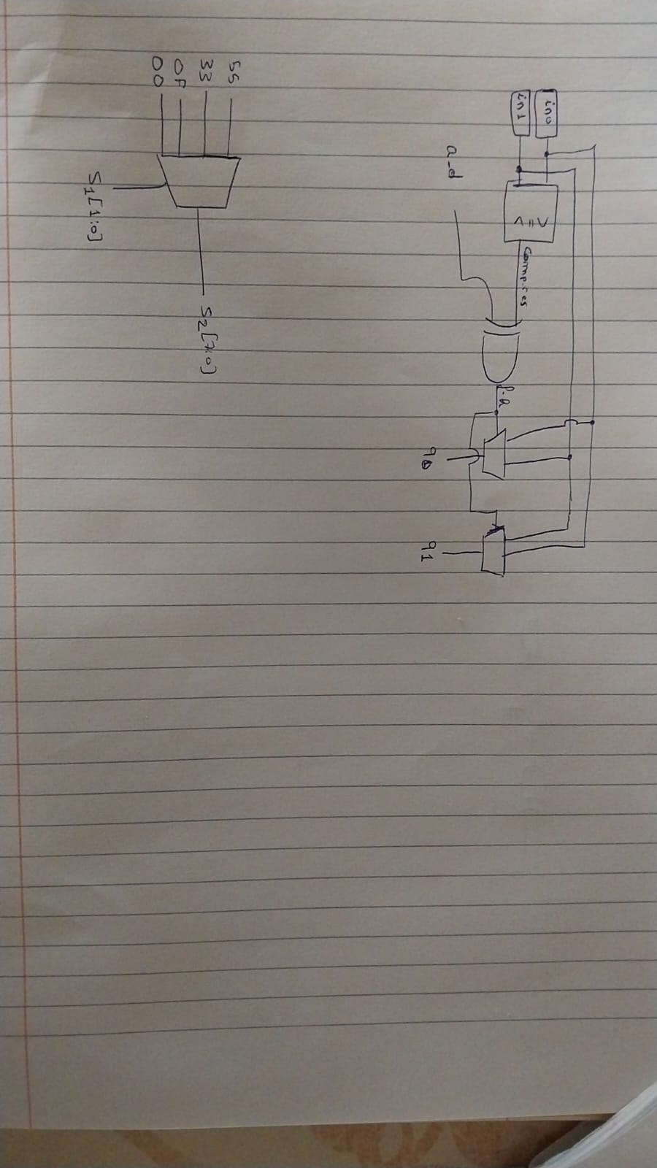
Figure 2 compare block

First, we created a component named compare, this component is responsible of comparing two input values of 8 bits each. The comparison is performed using a "less than" comparator. The output of this comparison is a 1-bit value, where '0' indicates that the values are greater than or equal, and '1' indicates that the first value is less than the second value. In the code, this output is referred to as "comp_res" The following truth table illustrates the behavior of this "compare" block.

Table 2 compare block table.
a_d | Comp_res | F_h | Q0 | Q1
0 | 0 | 0 | In0 | In1
0 | 1 | 1 | In1 | In0
1 | 0 | 1 | In1 | In0
1 | 1 | 0 | In0 | In1
A_d is for either ascending (1) or descending(0)
F_h is to decide wether to flip(1) the 2 numbers or hold(0)
In the algorithm, comparisons are made between two numbers at each step, and these numbers change as the algorithm progresses. The truth table provided reveals an interesting pattern: when a line is drawn between the rows where the 'in1' value is equal to 7 and 8, a symmetrical structure can be observed. Each pair of rows, such as 7 and 8, 6 and 9, 5 and 10, etc., have complementary patterns of filled and empty places denoted by 'X'. This symmetry allows for combining these pairs of rows using multiplexers in the hardware implementation. By utilizing two multiplexers—one for the corresponding 'in1' values and another for selecting the appropriate rows—the resulting combination forms the two values to be compared in the algorithm. This merging technique takes advantage of the symmetry in the table and enables an efficient hardware implementation of the required comparisons.

Table 3 in0 and in1 table
In0 | In1
0 | 1 | 2 | 4 | 8
1 | X | 3 | 5 | 9
2 | 3 | X | 6 | 10
3 | X | X | 7 | 11
4 | 5 | 6 | X | 12
5 | X | 7 | X | 13
6 | 7 | X | X | 14
7 | X | X | X | 15
8 | 9 | 10 | 11 | X
9 | X | 11 | 12 | X
10 | 11 | X | 13 | X
11 | X | X | 15 | X
12 | 13 | 14 | X | X
13 | X | 15 | X | X
14 | 15 | X | X | X
15 | X | X | X | X

After, that we combine the lines inside this table so we get the new table of how our multiplexers should be:
Table 4 mux inputs to the compare blocks
In0 |  | In1
0 | 0 | 1 | 2 | 4 | 8
1 | 14 | 15 | 3 | 5 | 9
2 | 13 | 3 | 15 | 6 | 10
3 | 12 | 13 | 14 | 7 | 11
4 | 11 | 5 | 6 | 15 | 12
5 | 10 | 11 | 7 | 14 | 13
6 | 9 | 7 | 11 | 13 | 14
7 | 8 | 9 | 10 | 11 | 15

We also add s1 and s2 as select lines for muxes of in0 and in1.
S1: For S1, we have 4 possibilities that are present because of the nature of the bitonic sorting algorithm, first we can compare consecutive values, values that are spaced by 1 value, 2 values or 8 values, therfore s1 will take (00,01,10,11) which will be responsible for selecting these 4 stages mentioned above
S2: s2 will be influenced by the values of s1, so s2 will have 0x55, 0x33, 0xF0, 0x00 depending on s1 respectively.

Figure 3 relation between s1 and s2
Input to registers:
To ensure that values can be returned to the register after each step, it is necessary to match the appropriate output with its corresponding input. The table below demonstrates the mapping of internal outputs to the respective register inputs, taking into account the displacement in the comparisons and the intricate selection of value comparisons.
Table 5 feedback registers
R | 00 | 01 | 10 | 11
0 | Int_q0 | Int_q0 | Int_q0 | Int_q0
1 | Int_q1 | Int_q2 | Int_q2 | Int_q2
2 | Int_q4 | Int_q1 | Int_q4 | Int_q4
3 | Int_q5 | Int_q3 | Int_q6 | Int_q6
4 | Int_q8 | Int_q8 | Int_q1 | Int_q8
5 | Int_q9 | Int_q10 | Int_q3 | Int_q10
6 | Int_q12 | Int_q9 | Int_q5 | Int_q12
7 | Int_q13 | Int_q11 | Int_q7 | Int_q14
8 | Int_q14 | Int_q14 | Int_q14 | Int_q1
9 | Int_q15 | Int_q12 | Int_q12 | Int_q3
10 | Int_q10 | Int_q15 | Int_q10 | Int_q5
11 | Int_q11 | Int_q13 | Int_q8 | Int_q7
12 | Int_q6 | Int_q6 | Int_q15 | Int_q9
13 | Int_q7 | Int_q4 | Int_q13 | Int_q11
14 | Int_q2 | Int_q7 | Int_q11 | Int_q13
15 | Int_q3 | Int_q5 | Int_q9 | Int_q15

State machine:
In order to control the process of inputing the data into the comparators, we need a controller which is a state machine made out of 4 states:

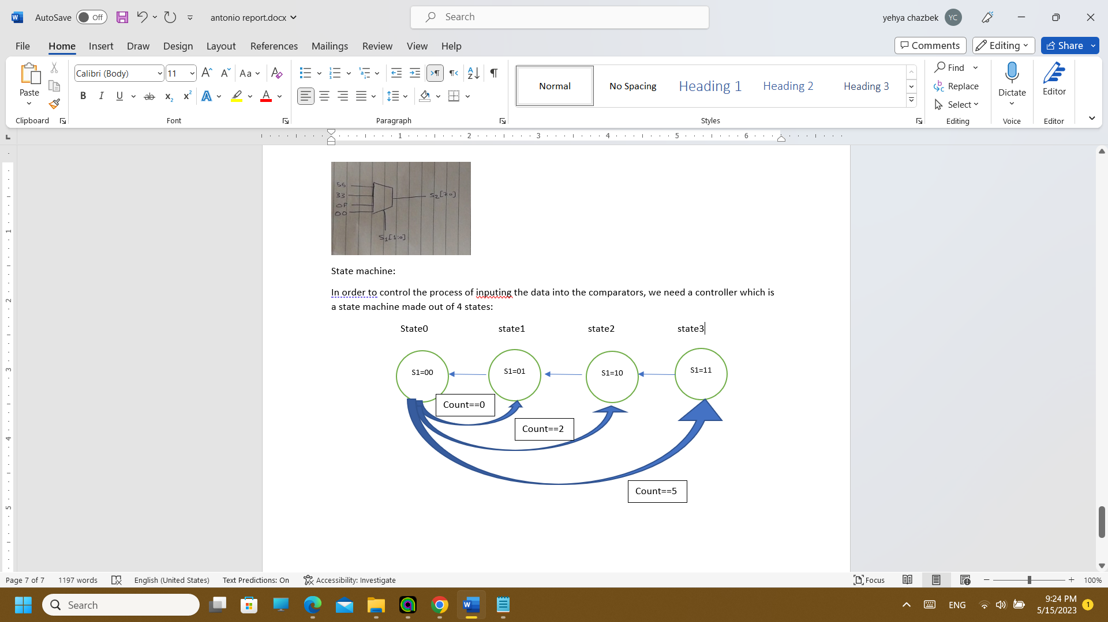
Figure 4 state machine
The select line "s1" is the only line affected, as depicted in the figure above. However, a cascading effect occurs when "s1" changes its value. This change in "s1" impacts "s2," the multiplexers leading to the comparators' inputs, and the multiplexers responsible for the feedback into the registers.
Regarding the count, Table 1 illustrates that 10 steps are required to reach the final output when using the Bitonic sort algorithm to sort a sequence of 16 numbers. As depicted in Figure 4, there are 4 states, with some states repeating throughout the 10 steps. To navigate to the appropriate state, a counter is utilized. At each rising edge of the clock, the counter is incremented by 1 until it reaches the value of 10. This counter facilitates effective state management.
Table 6 relation between counter and states
Counter | State:
0 | State0
1 | State1
2 | State0
3 | State2
4 | State1
5 | State0
6 | State3
7 | State2
8 | State1
9 | State0

a_d: Finally the a_d select line will also be determined based on the counter value as follows:
Table 7 relation between counter and a_d
Counter | A_d:
0 | 10011001
1 | 11000011
2 | 10100101
3 | 11110000
4 | 11001100
5 | 10101010
6 | 11111111
7 | 11111111
8 | 11111111
9 | 11111111

Alternative solutions:
There are various approaches to implementing this project using SystemVerilog and hardware implementations. The approach we selected involves a global state machine that governs the main signal, along with a custom comparator block.
An alternative approach would be to employ two state machines: a global state machine and a local state machine. The global state machine would resemble the one we implemented, while the local state machine would control the comparison step instead of a separate logic submodule. It would involve deciding whether to flip or retain the input values, similar to the "compare" block, but implemented using states. However, for our project, we opted not to pursue this approach as we found it more straightforward to implement a logic submodule, which offers comparable hardware efficiency and speed.
Another alternative method would be to control all signals within the states of the global state machine, without relying on a counter. Consequently, the FSM would consist of 10 states instead of 4, with each state determining all select lines and required values. However, this approach is less efficient and less conducive to clean code compared to the approach we chose, which is why we stuck with the method explained above.

Simulation:
We tested our design using the simulation tool available on Quatrus software:
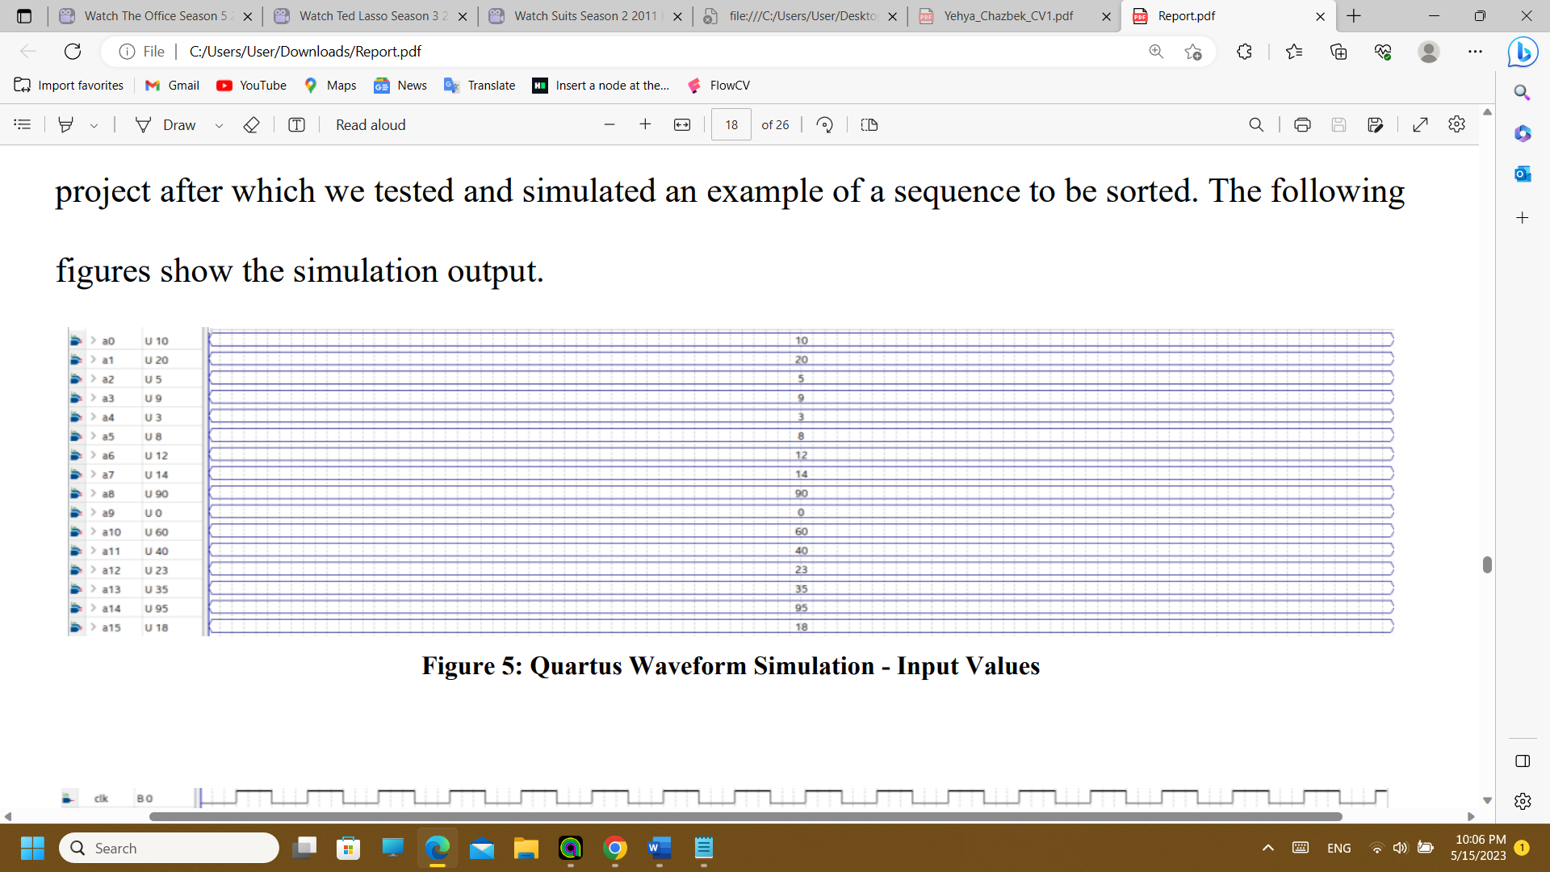
Figure 5 input values
Output values:
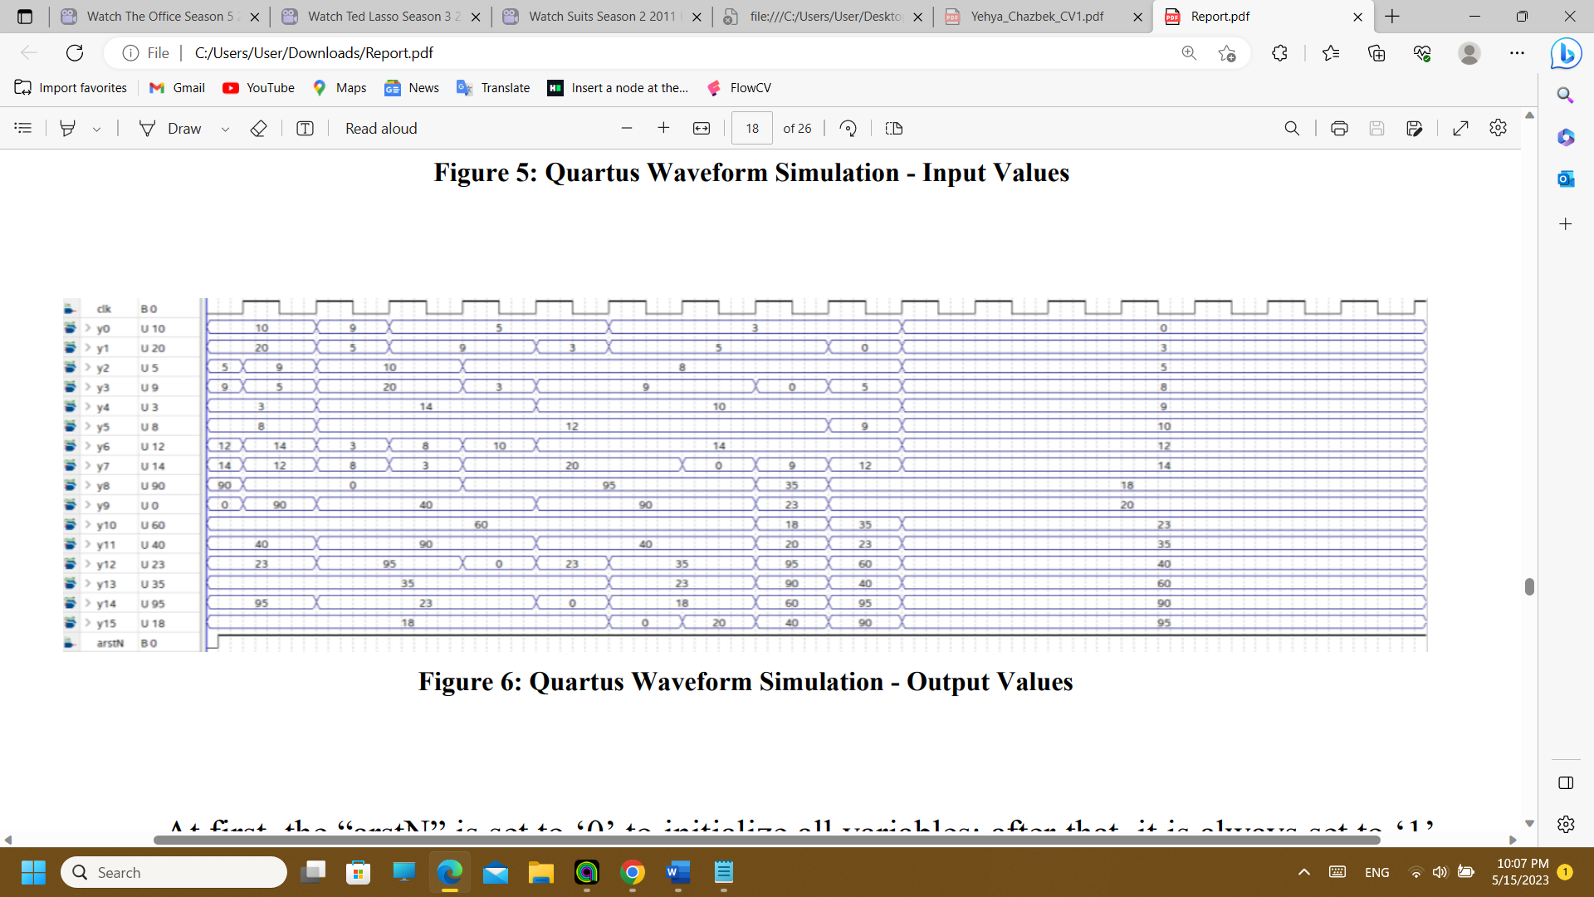
Figure 6 ouput values
Initially, the "arstN" signal is set to '0' to initialize all variables, and subsequently, it is always set to '1'. With each rising edge of the clock, the code progresses from one state to another, completing all 10 steps of the sorting algorithm in question. At each step, the values are either flipped or held in place, as depicted in Figure 6. The final output value, shown on the right side of Figure 6, is held due to the "CE" (Clock Enable) signal being set to '0' after the 10 steps of the code execution.
In Figure 5, which represents a Quartus waveform simulation for input values, and Figure 6, illustrating the output values, the hardware logic and the written code for this project demonstrate the successful sorting of a sequence containing 16 numbers, each consisting of 8 bits, in ascending order.
We conducted tests using various clock values, and even at extremely fast clocks (0.01ns), the sequence was properly sorted. However, for the sake of visibility and analysis, the provided simulation is set with a clock period of 30ns.

Conclusion:
in conclusion, we successfully did a design and implementation of a bitconic sorter using SystemVerilog, we achieved that by creating a comparator that eighter flips the numbers location or keep it as is and after some iterations it can sort a list of numbers in the ascending order.

Code:
module bitonic_sort (input logic [7:0] i0, i1, i2, i3, i4, i5, i6, i7, i8,
i9, i10, i11, i12, i13, i14, i15,
input logic clk, arstN,
output logic [7:0] q0, q1, q2, q3, q4, q5, q6, q7,
q8, q9, q10, q11, q12, q13, q14, q15);

typedef enum logic [3:0] {state0 = 4'b0001,
state1 = 4'b0010,
state2 = 4'b0100,
state3 = 4'b1000} state_t;
state_t state_next, state_reg;

logic [7:0] r_next0, r_next1, r_next2, r_next3,
r_next4, r_next5, r_next6, r_next7,
r_next8, r_next9, r_next10, r_next11,
r_next12, r_next13, r_next14, r_next15,
r_reg0, r_reg1, r_reg2, r_reg3,
r_reg4, r_reg5, r_reg6, r_reg7,
r_reg8, r_reg9, r_reg10, r_reg11,
r_reg12, r_reg13, r_reg14, r_reg15;
logic CE;

logic [7:0] l0_c0, l0_c1, l0_c2, l0_c3, l0_c4, l0_c5, l0_c6, l0_c7,
l1_c0, l1_c1, l1_c2, l1_c3, l1_c4, l1_c5, l1_c6, l1_c7;
logic [7:0] a_d;
logic [1:0] s1;
logic [6:0] s2;
logic [7:0] int_q0, int_q1, int_q2, int_q3, int_q4, int_q5, int_q6, int_q7,
int_q8, int_q9, int_q10, int_q11, int_q12, int_q13, int_q14, int_q15;

logic [3:0] count_reg, count_next;

always_ff @(posedge clk, negedge arstN)
if(!arstN) begin
state_reg <= state0;
r_reg0 <= i0;
r_reg1 <= i1;
r_reg2 <= i2;
r_reg3 <= i3;
r_reg4 <= i4;
r_reg5 <= i5;
r_reg6 <= i6;
r_reg7 <= i7;
r_reg8 <= i8;
r_reg9 <= i9;
r_reg10 <= i10;
r_reg11 <= i11;
r_reg12 <= i12;
r_reg13 <= i13;
r_reg14 <= i14;
r_reg15 <= i15;
count_reg <= 'b0;
end
else if(CE) begin
state_reg <= state_next;
r_reg0 <= r_next0;
r_reg1 <= r_next1;
r_reg2 <= r_next2;
r_reg3 <= r_next3;
r_reg4 <= r_next4;
r_reg5 <= r_next5;
r_reg6 <= r_next6;
r_reg7 <= r_next7;
r_reg8 <= r_next8;
r_reg9 <= r_next9;
r_reg10 <= r_next10;
r_reg11 <= r_next11;
r_reg12 <= r_next12;
r_reg13 <= r_next13;
r_reg14 <= r_next14;
r_reg15 <= r_next15;
count_reg <= count_next;
end

assign q0 = r_reg0;
assign q1 = r_reg1;
assign q2 = r_reg2;
assign q3 = r_reg3;
assign q4 = r_reg4;
assign q5 = r_reg5;
assign q6 = r_reg6;
assign q7 = r_reg7;
assign q8 = r_reg8;
assign q9 = r_reg9;
assign q10 = r_reg10;
assign q11 = r_reg11;
assign q12 = r_reg12;
assign q13 = r_reg13;
assign q14 = r_reg14;
assign q15 = r_reg15;

always_comb begin
case (s1)
2'b00: begin
s2 = 7'b1010101;
l1_c0 = r_reg1;
l1_c1 = r_reg15;
l1_c2 = r_reg3;
l1_c3 = r_reg13;
l1_c4 = r_reg5;
l1_c5 = r_reg11;
l1_c6 = r_reg7;
l1_c7 = r_reg9;
end
2'b01: begin
s2 = 7'b0110011;
l1_c0 = r_reg2;
l1_c1 = r_reg3;
l1_c2 = r_reg15;
l1_c3 = r_reg14;
l1_c4 = r_reg6;
l1_c5 = r_reg7;
l1_c6 = r_reg11;
l1_c7 = r_reg10;
end
2'b10: begin
s2 = 7'b0001111;
l1_c0 = r_reg4;
l1_c1 = r_reg5;
l1_c2 = r_reg6;
l1_c3 = r_reg7;
l1_c4 = r_reg15;
l1_c5 = r_reg14;
l1_c6 = r_reg13;
l1_c7 = r_reg12;
end
2'b11: begin
s2 = 7'b0000000;
l1_c0 = r_reg8;
l1_c1 = r_reg9;
l1_c2 = r_reg10;
l1_c3 = r_reg11;
l1_c4 = r_reg12;
l1_c5 = r_reg13;
l1_c6 = r_reg14;
l1_c7 = r_reg15;
end
endcase
end

assign l0_c1 = s2[6] ? r_reg14 : r_reg1;
assign l0_c2 = s2[5] ? r_reg13 : r_reg2;
assign l0_c3 = s2[4] ? r_reg12 : r_reg3;
assign l0_c4 = s2[3] ? r_reg11 : r_reg4;
assign l0_c5 = s2[2] ? r_reg10 : r_reg5;
assign l0_c6 = s2[1] ? r_reg9 : r_reg6;
assign l0_c7 = s2[0] ? r_reg8 : r_reg7;

always_comb begin
a_d = 'b0;
CE = 1'b1;
unique case (count_reg)
4'b0000: a_d = 8'b10011001;
4'b0001: a_d = 8'b11000011;
4'b0010: a_d = 8'b10100101;
4'b0011: a_d = 8'b11110000;
4'b0100: a_d = 8'b11001100;
4'b0101: a_d = 8'b10101010;
4'b0110: a_d = 8'b11111111;
4'b0111: a_d = 8'b11111111;
4'b1000: a_d = 8'b11111111;
4'b1001: a_d = 8'b11111111;
4'b1010: CE = 1'b0;
endcase
end

compare c0(r_reg0, l1_c0, a_d[7], int_q0, int_q1);
compare c1(l0_c1, l1_c1, a_d[6], int_q2, int_q3);
compare c2(l0_c2, l1_c2, a_d[5], int_q4, int_q5);
compare c3(l0_c3, l1_c3, a_d[4], int_q6, int_q7);
compare c4(l0_c4, l1_c4, a_d[3], int_q8, int_q9);
compare c5(l0_c5, l1_c5, a_d[2], int_q10, int_q11);
compare c6(l0_c6, l1_c6, a_d[1], int_q12, int_q13);
compare c7(l0_c7, l1_c7, a_d[0], int_q14, int_q15);

always_comb begin
r_next0 = int_q0;
case (s1)
2'b00: begin
r_next1 = int_q1;
r_next2 = int_q4;
r_next3 = int_q5;
r_next4 = int_q8;
r_next5 = int_q9;
r_next6 = int_q12;
r_next7 = int_q13;
r_next8 = int_q14;
r_next9 = int_q15;
r_next10 = int_q10;
r_next11 = int_q11;
r_next12 = int_q6;
r_next13 = int_q7;
r_next14 = int_q2;
r_next15 = int_q3;
end
2'b01: begin
r_next1 = int_q2;
r_next2 = int_q1;
r_next3 = int_q3;
r_next4 = int_q8;
r_next5 = int_q10;
r_next6 = int_q9;
r_next7 = int_q11;
r_next8 = int_q14;
r_next9 = int_q12;
r_next10 = int_q15;
r_next11 = int_q13;
r_next12 = int_q6;
r_next13 = int_q4;
r_next14 = int_q7;
r_next15 = int_q5;
end
2'b10: begin
r_next1 = int_q2;
r_next2 = int_q4;
r_next3 = int_q6;
r_next4 = int_q1;
r_next5 = int_q3;
r_next6 = int_q5;
r_next7 = int_q7;
r_next8 = int_q14;
r_next9 = int_q12;
r_next10 = int_q10;
r_next11 = int_q8;
r_next12 = int_q15;
r_next13 = int_q13;
r_next14 = int_q11;
r_next15 = int_q9;
end
2'b11: begin
r_next1 = int_q2;
r_next2 = int_q4;
r_next3 = int_q6;
r_next4 = int_q8;
r_next5 = int_q10;
r_next6 = int_q12;
r_next7 = int_q14;
r_next8 = int_q1;
r_next9 = int_q3;
r_next10 = int_q5;
r_next11 = int_q7;
r_next12 = int_q9;
r_next13 = int_q11;
r_next14 = int_q13;
r_next15 = int_q15;
end
endcase
end

always_comb begin
unique case (state_reg)
state0: begin
s1 = 2'b00;
state_next = (count_reg == 4'b0000) ? state1 :
(count_reg == 4'b0010) ? state2 :
state3;
end
state1: begin
s1 = 2'b01;
state_next = state0;
end
state2: begin
s1 = 2'b10;
state_next = state1;
end
state3: begin
s1 = 2'b11;
state_next = state2;
end
endcase
end

assign count_next = count_reg + 4'b0001;

endmodule

code for comparator:
module compare (input logic [7:0] in0, in1,
input logic a_d,
output logic [7:0] q0, q1);

logic comp_res, f_h;
assign comp_res = in0 < in1;
assign f_h = a_d ^ comp_res;
assign out0 = f_h ? in1 : in0;
assign out1 = f_h ? in0 : in1;

endmodule

